DAA OUTPUT (1-5):

1) Implementation and Performance Analysis of
Interpolation Search

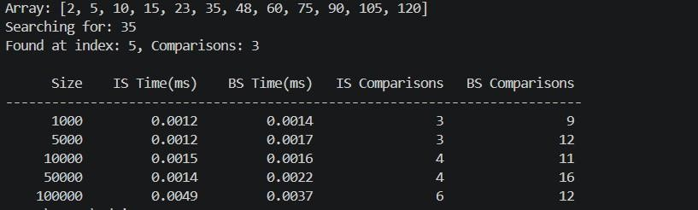

2)Comparative Analysis of Naive, Rabin-Karp, and KMP Algorithms for String Matching

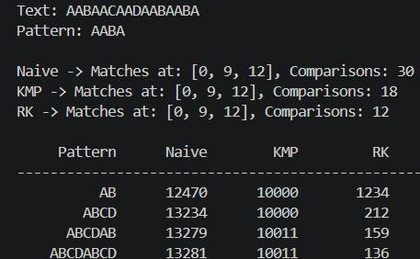

3)Implementation of Kruskal's and Prim's Algorithms for Minimum Spanning Tree

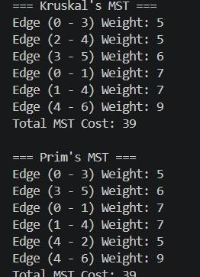

4)Implementation of Single Source Shortest Path Algorithm (Dijkstra's)

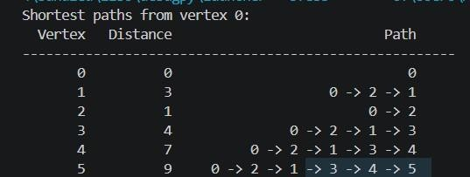

5)To find the MIN-Max by applying Divide and Conquer technique

